**SARDAR PATEL INSTITUTE OF TECHNOLOGY**

MUNSHI NAGAR, ANDHERI (WEST), MUMBAI 400 058.

A REPORT ON

HIGHWAY RUNNERS

A MINI PROJECT USING PHP AND MYSQL

**THIRD YEAR**

**INFORMATION TECHNOLOGY**

**DEVELOPED BY:**

Priyanka Tavar

VeenaWagle

**GUIDED BY**:

MRS. Uma Nashte

**ACADEMIC YEAR**

**2012**

**CERTIFICATE**

This is to certify that the following students have successfully completed the mini project and presented their report on HIGHWAY RUNNERS using PHP and MYSQL in view of the course in Engineering. This project is a partial fulfillment of degree according to the syllabus of Mumbai University for Semester-VI IT students, for the academic year 2012.

**GROUP MEMBERS:**

Priyanka Tavar

VeenaWagle

_______________ _______________

**Date** **Sign of Guide**

**Acknowledgements**

After the completion of this project, as we look back in retrospect, we find a lot of people who have helped us in our project. We express our sincere gratitude to our guide Mrs. Uma Nashte for her timely and valuable suggestions without whom this project wouldn’t have been a success. Her suggestions were always there whenever we needed. We would also like to thank all our colleagues and friends who have been always there to help us and also our family members, who helped us directly or indirectly in the completion of this project.

**CONTENTS**

|  |  |  |
| --- | --- | --- |
| **Sr. No.** | **Topic** | **Page No.** |
| 1 | Problem Definition | 1 |
| 2 | System Requirements | 3 |
| 3 | Specification | 8 |
| 4 | Snapshots | 10 |
| 5 | Conclusion | 52 |
| 6 | References |  |

**PROBLEM DEFINITION**

**AIM:**

The request for proposal of project forIPfor topic ‘Highway Runners’.

**OBJECTIVE:**

To create a travel Agency site that is more user-friendly.

**CASE STUDY:**

* ***“HIGHWAY RUNNERS*”**is an onlinetravel agency site providingfacility to book various tour packages are available.
* In this the user can also book flight tickets of various airways such as kingfisher, jet airways,Air India.
* Booking of Railway tickets is also available.
* After booking any of the tours packages or tickets of airoplane or railways the user get automatically registered in the database.
* While filing the booking form customer enters a password which he will use the next time he visits our website.
* The project provides an userfriendly way for booking of tickets and tours seating at your home.

The data of the projectwill consist of :

1. royal_ratnagiri
2. ahmedabad_express
3. hi_goa
4. way_to_pune
5. wow_bangalore
6. gem_jalgaon
7. return_royal_ratnagiri
8. return_ahmedabad_express
9. return_hi_goa
10. return_way_to_pune
11. return_wow_bangalore
12. return_gem_jalgaon
13. tourist
14. rajdhani
15. duronto
16. august_kranti
17. shatabdi
18. air_deccan
19. air_india
20. kingfisher
21. jet_premium

The benefits of this project are as follows:

1. Requires less space to store information than the current system in use.
2. High speed of operating and accessing results.
3. Low overall cost and expenditure.
4. System gives quick view of details of various tour packages available

**Applications:**

1. The application can be useful for travel agencies
2. The application can be useful to have a look on different beautiful places in the world.

**SYSTEM REQUIREMENTS**

Software requirements: Apache Server, MYSQL, JRE 6,PHP

Operating System: Microsoft Windows 98/2000/XP/7

Processor: Pentium I 133 MHz or higher

Display: Resolution 800x600 or higher

**SPECIFICATION**

**About PHP**

**PHP** is a general-purpose scripting language originally designed for web development to produce dynamic web pages. For this purpose, PHP code is embedded into the HTML source document and interpreted by a web server with a PHP processor module, which generates the web page document. It also has evolved to include a command-line interface capability and can be used in standalone graphical applications. PHP can be deployed on most web servers and as a standalone interpreter, on almost every operating system and platform free of charge. PHP is installed on more than 20 million websites and 1 million web servers.

**Important Features of PHP:**

* PHP is accessible
* It's available for free
  + It's available with documentation in many languages
  + There are many support groups, forums, and teams supporting PHP
  + There is a wealth of online information regarding PHP
* It's quick to develop in PHP
* A basic PHP script can be created without a firm understanding of programming principals, compilation, and other currently important programming concepts
  + PHP is loosely typed, which makes basic scripts much faster to develop with less attention to design
* Programmers of Java, PERL, BASIC, and other popular languages can find many parallels to ease transition to PHP
* PHP is flexible. Use OOP or not. Use naming convention(s) or not
* It runs on many different operating systems
* It can be optimized, even "compiled" for performance closer to that of more established compiled languages

**MYSQL:**

**MySQL** is a relational database management system (RDBMS) that runs as a server providing multi-user access to a number of databases. The SQL phrase stands for Structured Query Language. MySQL is a popular choice of database for use in web applications, and is a central component of the widely used LAMP web application software stack—LAMP is an acronym for "Linux, Apache, MySQL, Perl/[PHP](http://en.wikipedia.org/wiki/PHP)/[Python](http://en.wikipedia.org/wiki/Python_(programming_language))". MySQL is used in some of the most frequently visited web sites on the Internet. MySQL ships with a suite of command-line tools for tasks such as querying the database, backing up data, inspecting status, performing common tasks such as creating a database, and many more.The MySQL Query Analyzer helps developers and DBAs improve application performance by monitoring query performance and accurately pinpointing SQL code that is causing a slow down. This paper explores common use cases and challenges faced by MySQL developers and DBAs in tuning SQL code. It also introduces the MySQL Query Analyzer and explains how it can be used to optimize queries during development and then to monitor applications in production environments.

**Important Features of MYSQL:**

* MySql is open source (so free), robust and fast. It is also easy to install on pretty much any operating system.
* It is easy to learn it on your own.
* It provides most of the features that a database like Oracle those.
* If are building a small to medium application it will most likely suit your needs.

**SNAPSHOTS**

**HOMEPAGE**

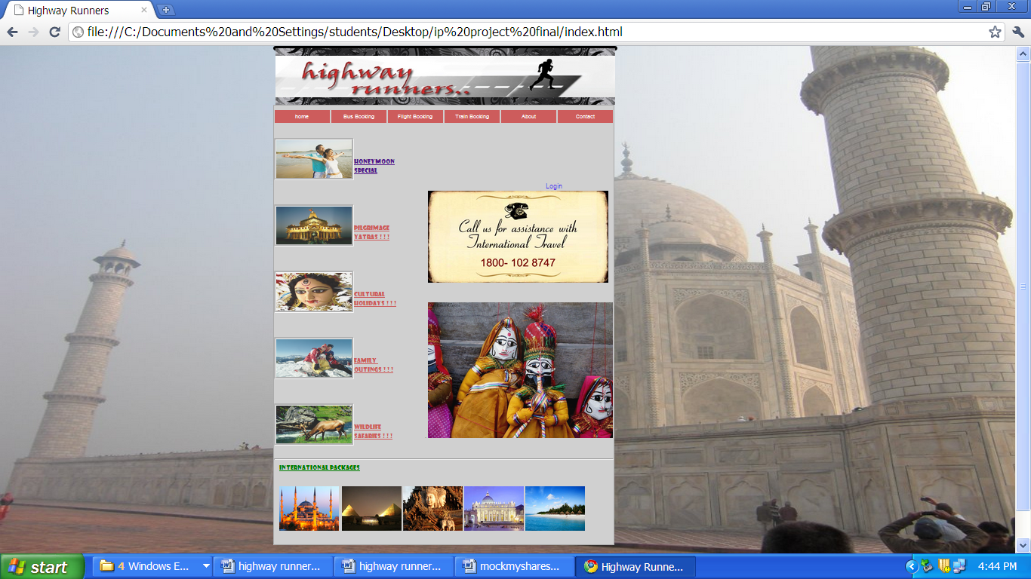

This is the homepage of our HIGHWAY RUNNERS website. It contains various tabs for home, bus booking, train booking, flight booking, about and contact. The page provides user with login facility. we have various links here to our different categories of packages.

**DIFFERENT CATEGORY OF PACKAGES**

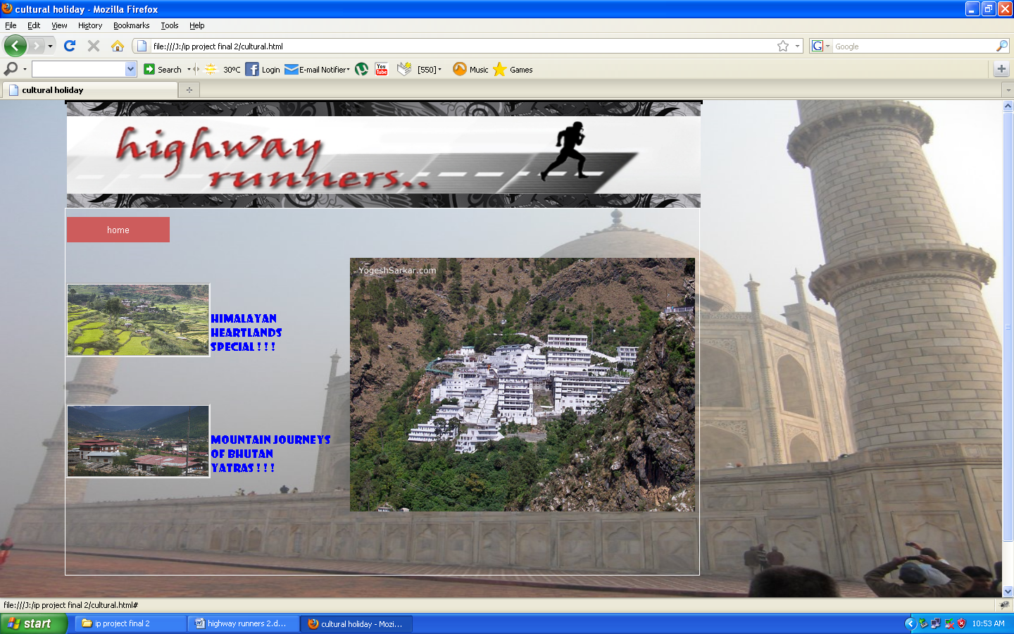

This page displays different tour packages available in each category.

**DESCRIPTION ABOUT EACH PACKAGE**

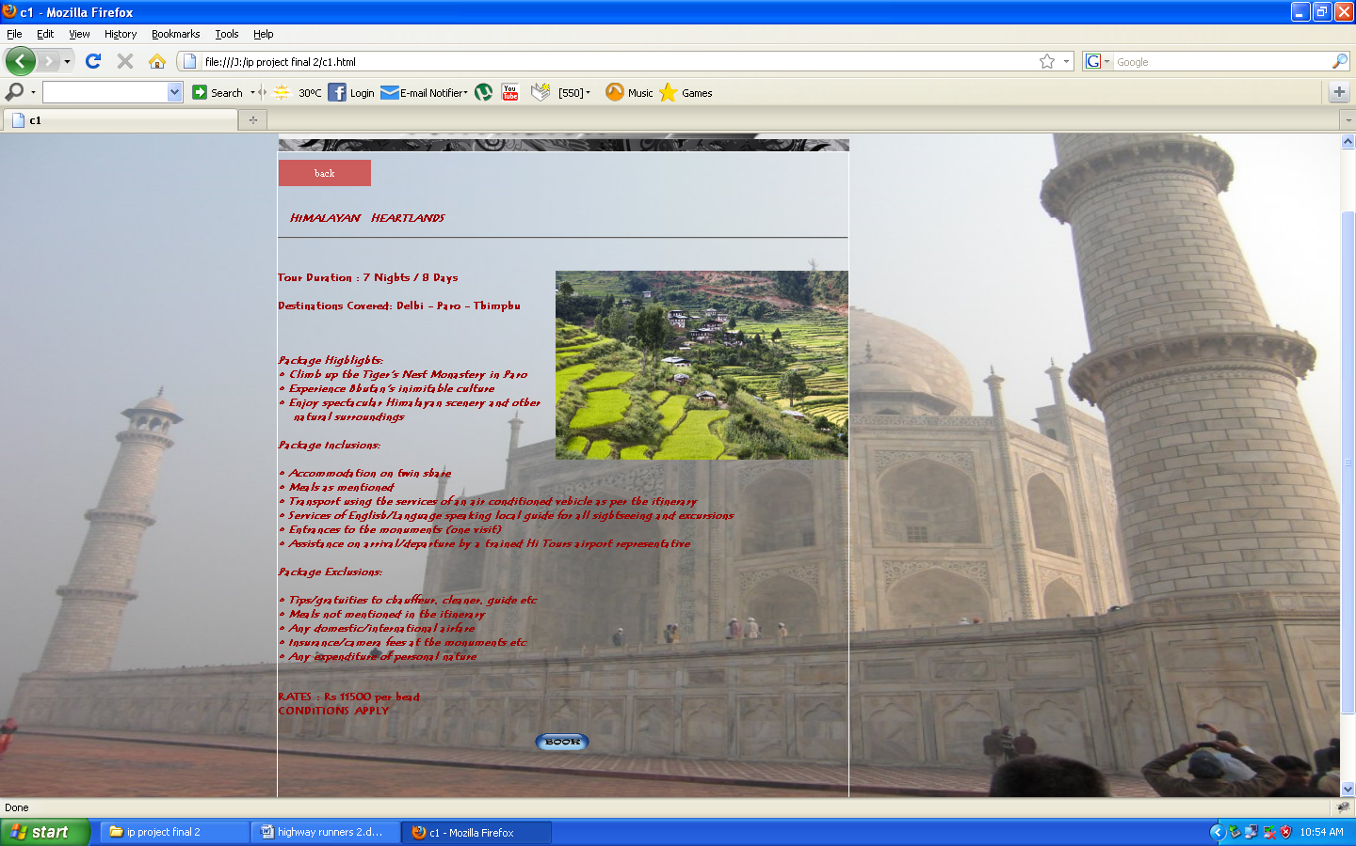

This displays the details of each package.

**BOOKING PAGE TO BOOK A SERVICE**

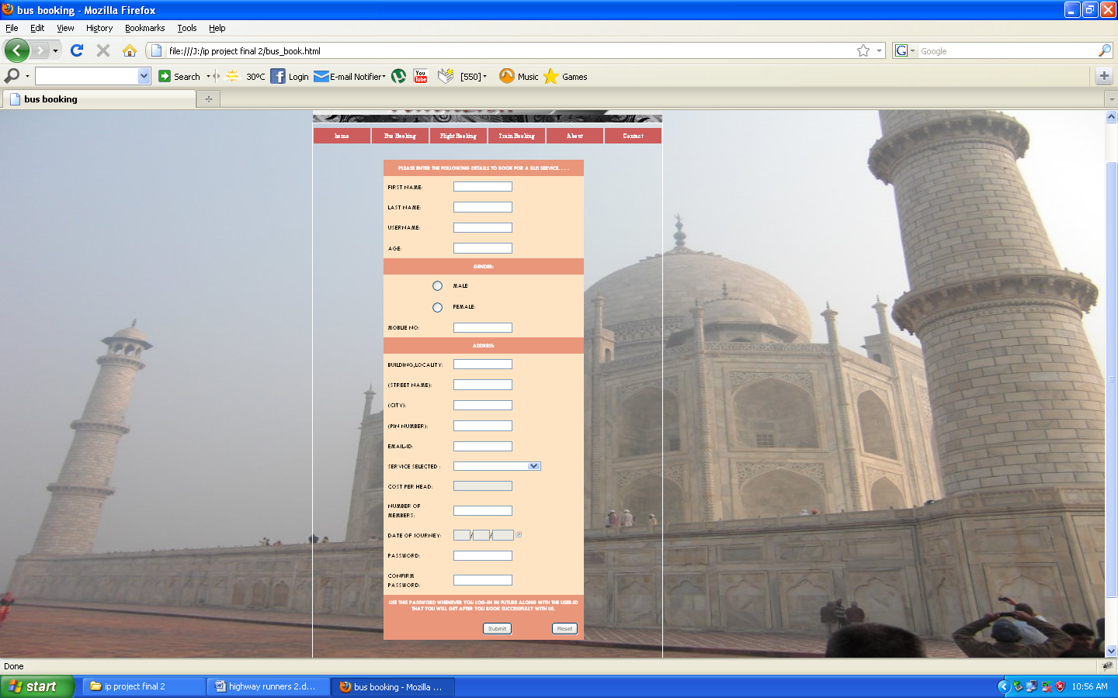

This is booking page of each service .user will fill details here.

**VALIDATION**

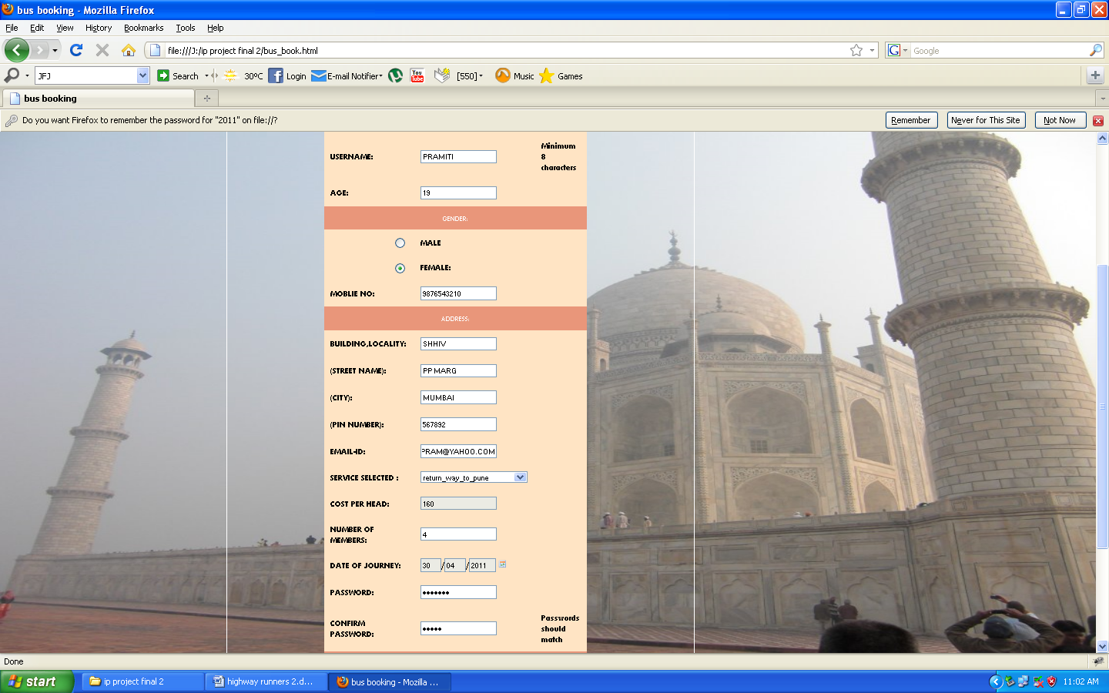

Performs validations. Checks whether the values entered by users satisfy certain conditions. If conditions are not satisfied errors will be displayed otherwise further processing will be done by php file.

**PHP page after booking**

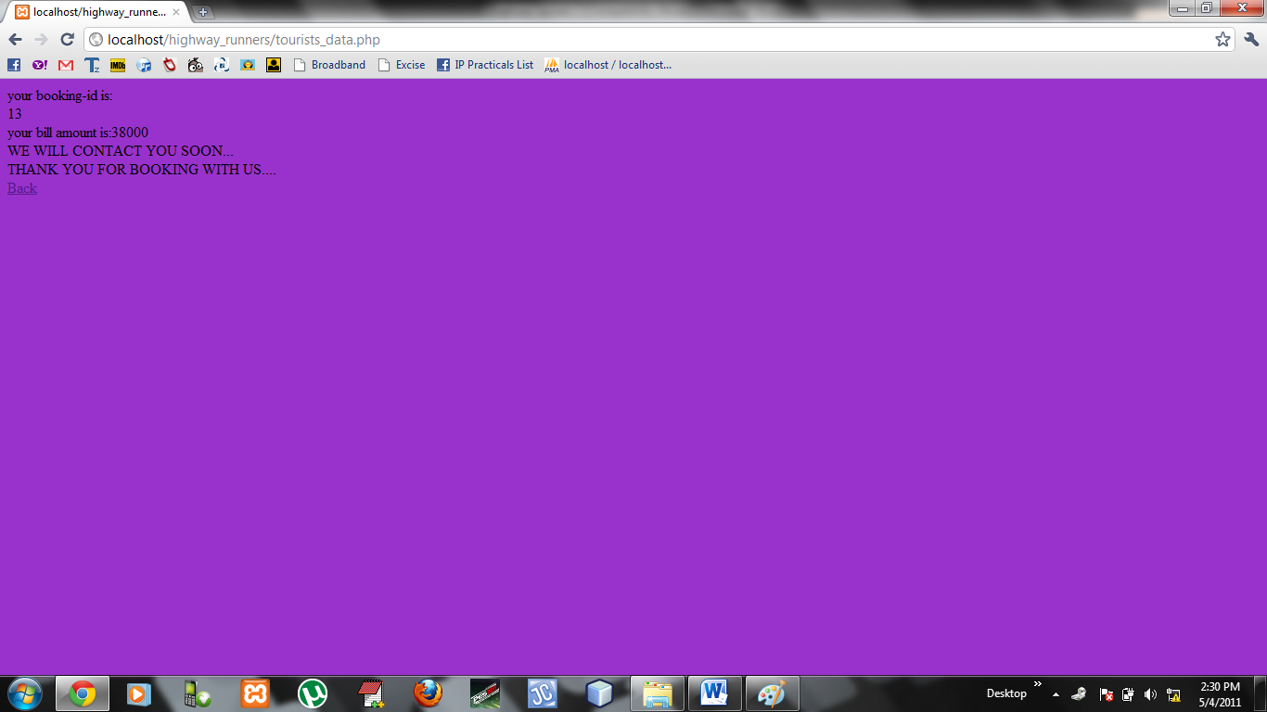

Displays the id and total amount and indicates that booking is done successfully.

**DATABASE**

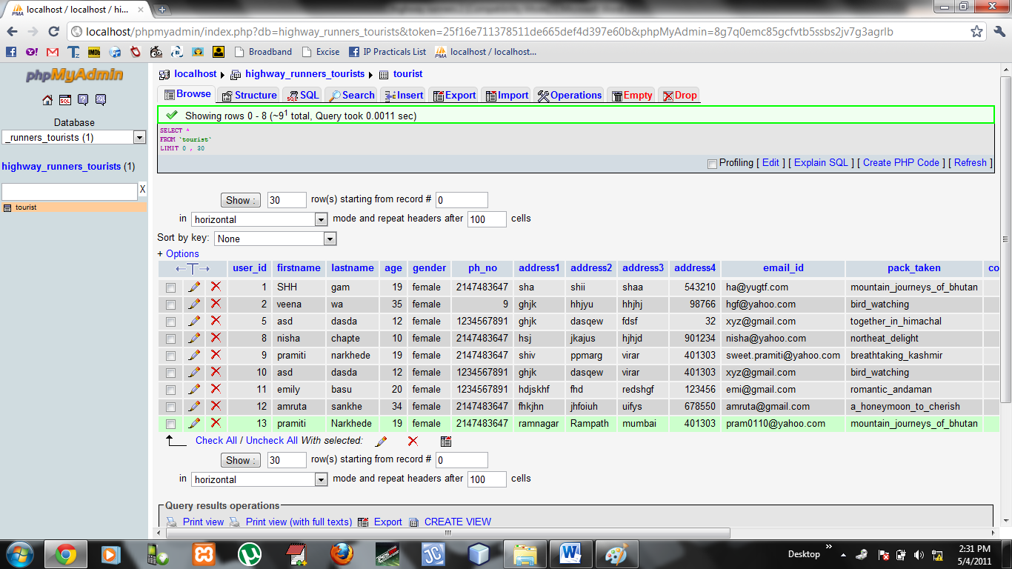

This page shows the database of the user who hasbooked the services.The latest entry has been entered in the database.

**LOG IN PAGE**

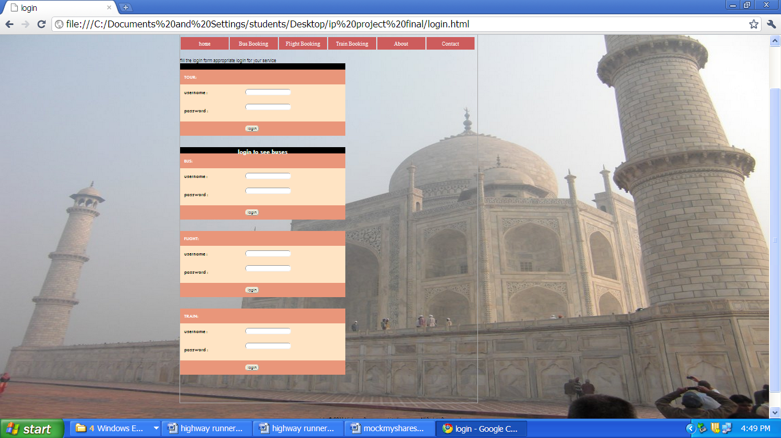

Login page to login .This web page is used by users who have already booked with us. there are 4 different log in slots available for seeing tourist packages, bus services, flight services, train services respectively from top to bottom that user has booked with us. For this the user has to enter username and password that the user had given while filling the form.

**BUS BOOKING**

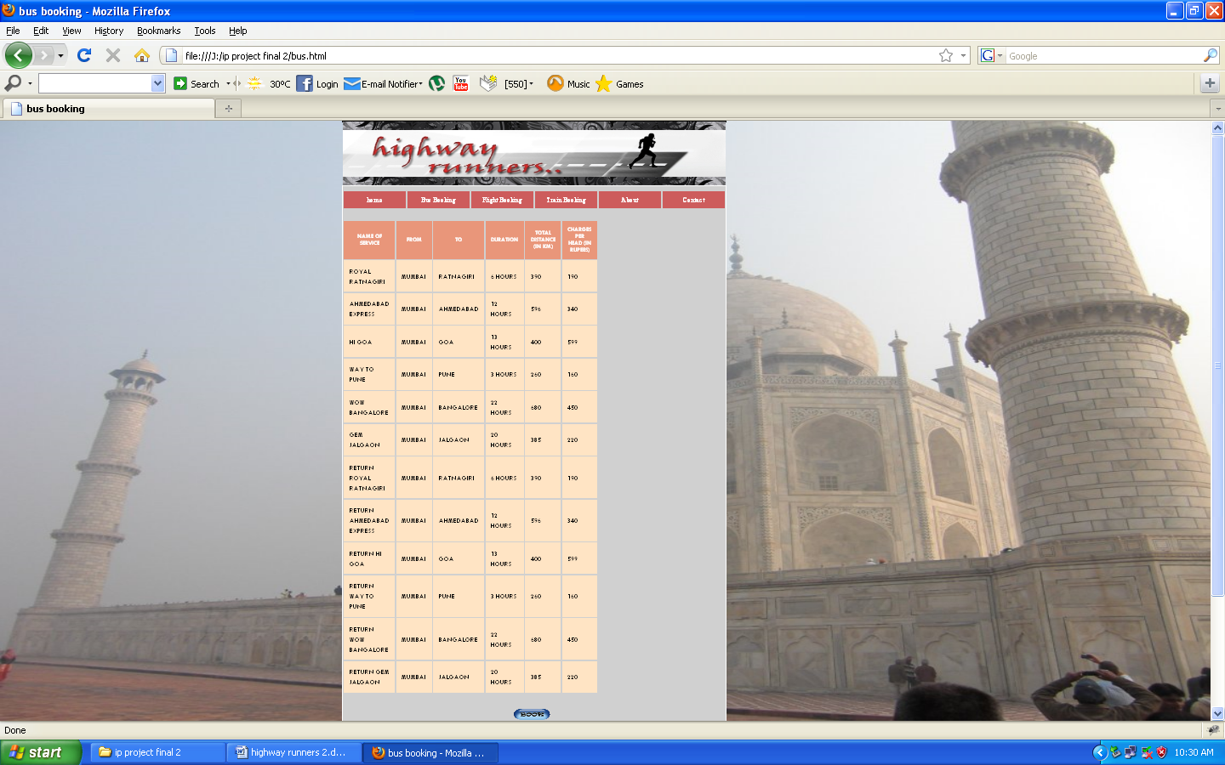

This page displays various buses available for journey. User can choose any of these . After clicking book button he will be directed to bus_book page where he has to fill all details. After booking these services user will be automatically registered in the database.

**TRAIN BOOKING**

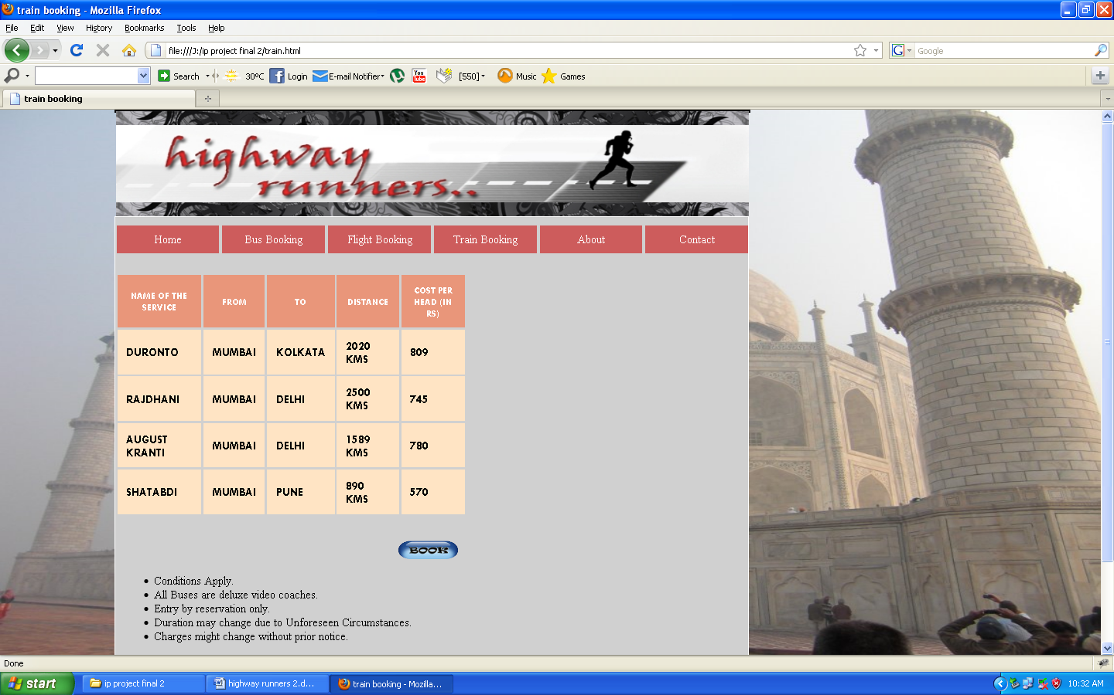

This page displays various trains available for journey. User can choose any of these . After clicking book button he will be directed to train_book page where he has to fill all details. After booking these services user will be automatically registered in the database.

**FLIGHT BOOKING**

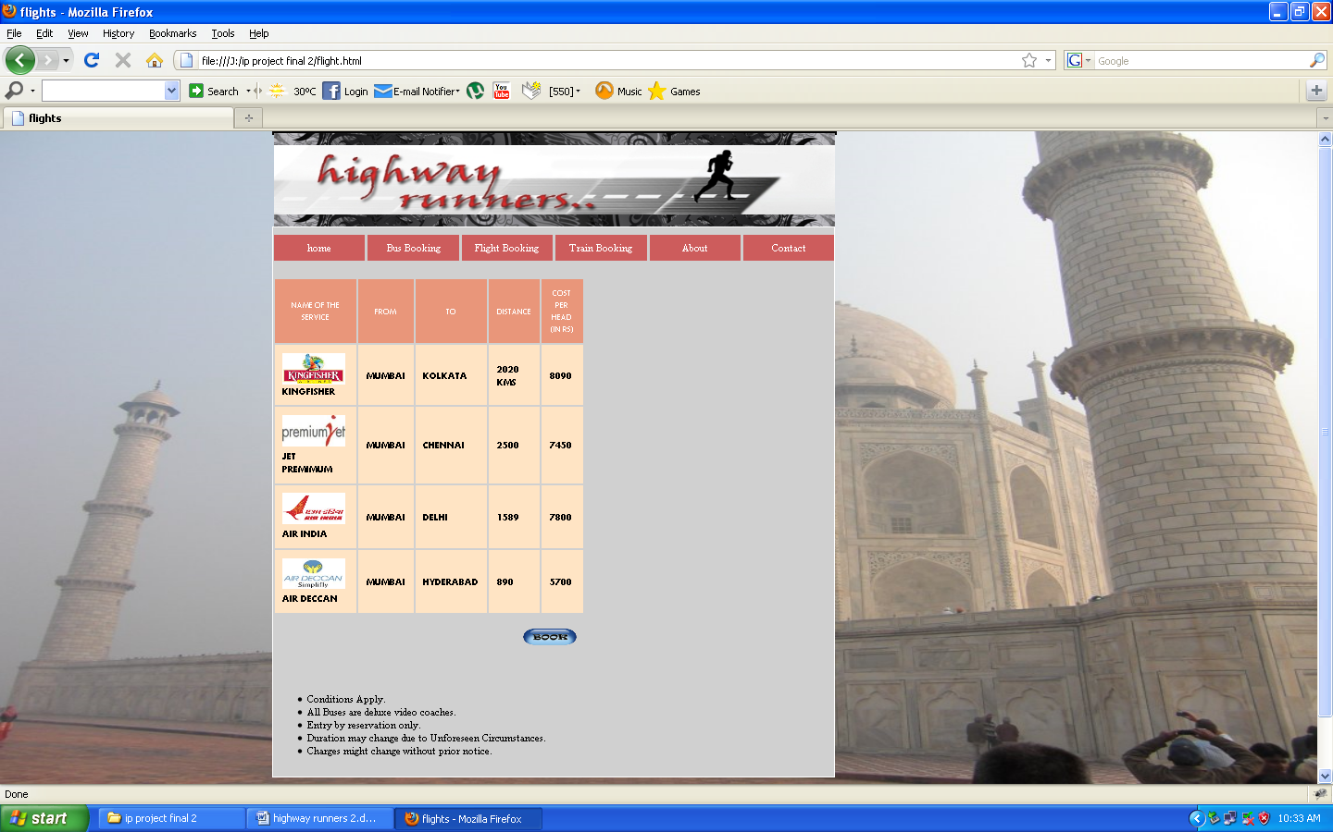

This page displays various flights available for journey. User can choose any of these . After clicking book button he will be directed to flight_book page where he has to fill all details. After booking these services user will be automatically registered in the database.

**ABOUT US**

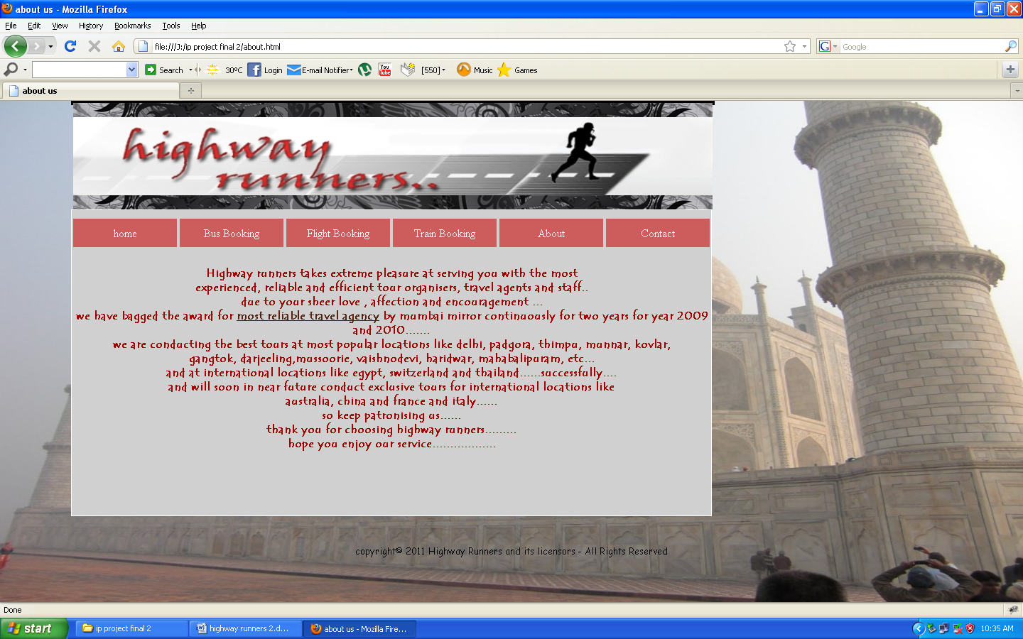

This page displays the details of company and history of journey of the company .

**CONTACT US**

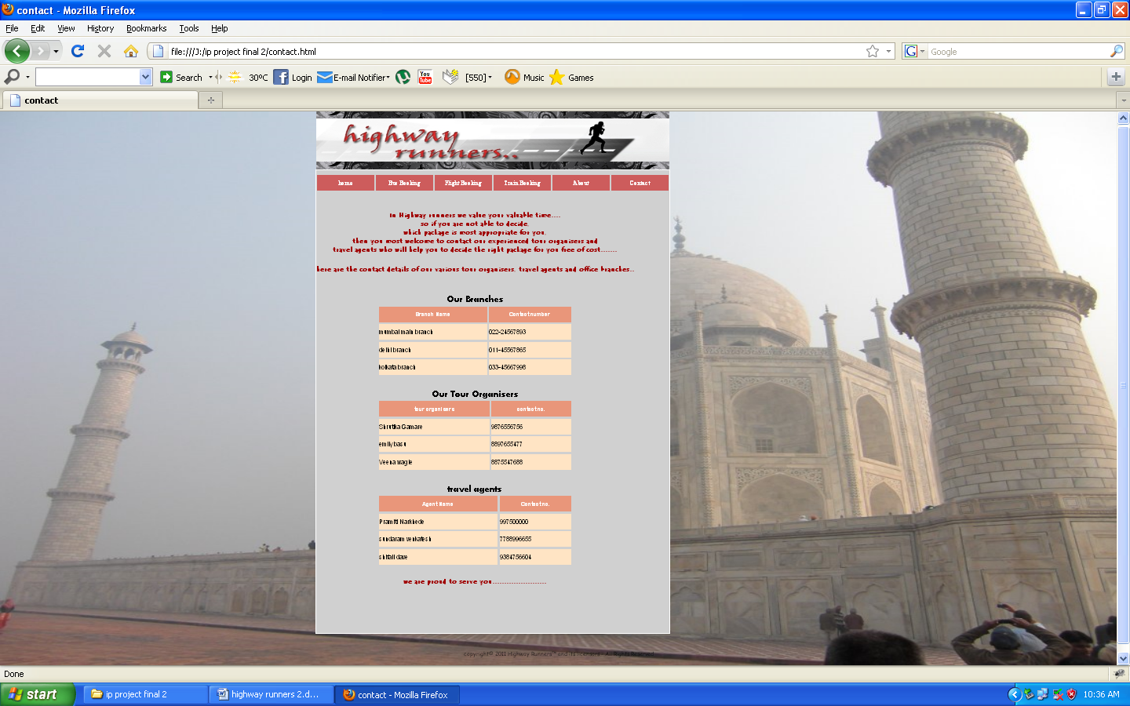

This page displays the contact number of our tour organizers and travel agents. Also provides information about different branches of company

**CONCLUSION**

Thus, this website has been designed so that the user can perform the online booking. The user doesn’t actually go to an office to book a ticket and stand in long queue. But he can book ticket seating at his place .It is extremely useful for customer who has to travel across the world everyday. This application makes the booking process easy and convenient. The system is user friendly and provides easy to understand User Interface.

**REFERENCES**

1. [*www.w3.org*](http://www.w3.org)
2. [*www.w3schools.com*](http://www.w3schools.com)
3. [*www.web****reference****.com*](http://www.webreference.com)
4. [*www.Jquerry.com*](http://www.Jquerry.com)
5. [*www.ajax.com*](http://www.ajax.com)